**Emergency Vehicle Traffic Management using Big Data in Internet of Vehicle**

Harman Singh, Arihant Sethia, Shivam Joshi and John Singh K

School of Information Technology, Vellore Institute of Technology, Vellore

***Abstract—*the term Big Data means huge amount of data which refers to some applications and study of sets of big and complex data. The traditional systems were not that much able to handle that much of data. Now days in this advance technical environment there are various applications to deal with these kinds of data. Big Data application used in various fields include remote sensing, internet of vehicles, security analytics, architecture design for smart grid, greening big data, fuzzy based scalable clustering algorithm, novel pipeline approach, visual analytics in urban computing etc. In today’s world enormous vehicular data is generated in terms of Traffic safety, all this data is generated by vehicles and the traffic signals and other navigational services. This data is used to manage the activities of vehicles for emergency services. Today lots of lives get lost due to delay in emergency services, many approaches for this problem has been proposed but not so efficient. In this paper, a new EVs traffic management system is proposed to cope up with this problem. The system uses Geo Location to track the distance between Traffic signal and EVs, and change the Traffic signal to green and shows the lane from which EVs is coming on the Traffic signal when it is within range of Traffic signal. This system will results in less delay in time of EVs in reaching the destination which in turn will helps in saving more lives.**

**Keywords-Emergency Vehicles (EVs), Road side units(RSU), Vehicular AdHoc Networks (Vanet), Roadside storage unit (RSU), Electronic Fuel Injection (EFI),Engine Control Unit (ECU), Vehicle to Vehicle(V2V) and Emergency Vehicle Management System** **( EVMS).**

I. Introduction:

The term Big Data means huge amount of data which refers to some applications and study of sets of big and complex data. The traditional systems were not that much able to handle that much of data. Now days in this advance technical environment there are various applications to deal with these kinds of data. Big Data is one of these applications that include various challenges like data storage, capturing data, sharing, data analysis, sharing, search, visualization, querying, information privacy, updating and data source. Big Data is associated with number of concepts mainly volume, variety, velocity. Some other concepts are also there that include veracity i.e., amount of noise in data and value. Big Data application used in various fields include remote sensing, internet of vehicles, security analytics, architecture design for smart grid, greening big data, fuzzy based scalable clustering algorithm, novel pipeline approach, visual analytics in urban computing etc. Big data is very messy and unstructured 50% to 80% Big data id to filter or sort the information so that it can used wisely, only few are capable in the cleanup of data, to do this cleanup special tool and techniques are used like Hadoop and HPE. Data has been a commodity that can used to generate money, as information is the most important thing as it can be used in various aspects in the market as major companies rely on this data or piece information’s to make their new products or services that results in money generation. Possibilities that Big data can provide are, Doctors can predict heart attacks before time, air traffic control can be managed well that may result in less air crashes and much more. If big data is not handled securely or any security measures are not taken then is huge data can be used for ill practices that can lead to cybercrime, terrorist attacks, leakage of personal or very important data that are sensitive. In today’s world enormous vehicular data is generated in terms of Traffic safety, all this data is generated by vehicles and the traffic signals and other navigational services. This data is of different type and which is in huge amount. All these kinds of data collected by vehicle to vehicle (V-V), vehicle to ground (V-G), vehicle to air (V-A), air to air (A-A), sensors, geo-location of vehicles, navigation. All these data are processed further and gather the useful information from the processed data; this information can be used in Traffic control, Travel time prediction, Vehicular communication, Information about vehicle like: engine health, pollution emission, tiers pressure, and other type of services. All this data is very difficult to handle so different strategies are used to manage data and provide useful information, one of the strategy that is commonly or widely used is BIG Data, here Big data plays a major role in the management of data that is generated by IOV’s and Big data gives some characterization, IoV Big Data sourcing, IoV Big Bata support, IoV Big Data services and applications. All these data are processed further and gather the useful information from the processed data; this information can be used in Traffic control, Travel time prediction, Vehicular communication, Information about vehicle like: engine health, pollution emission, tiers pressure, and other type of services.

In today’s time the major problem is the increasing traffic and to manage the traffic efficiently is very important, as number of the vehicles are increasing day by day it is the major problem, within this traffic some of vehicles are those who’s reaching to a destination is very critical and if they are not able to reach within time then some adverse effects may be there. These vehicles are known as emergency vehicles, these vehicles can be example: Patrolling cars (Police), Fire brigade trucks, Ambulance. So because of the insufficient traffic management these higher priority vehicles are not able to reach at a particular destination at time. To solve this problem, we have proposed an idea that we will be discussing ahead in the section IV with help of a scenario, images and block diagram.

II. Related work

Today’s vehicles are generating huge amount of data [1]. In big metropolitan cities traffic is major problem Internet of Vehicle is very helpful to traffic control and provide easy driving environment. This can be done through monitoring real-time data to prevent network failure. We can also use Aggregate signature for quick data verification. Internet of Vehicles also faces challenges regarding performance and security to overcome from this problem apply Difie-Hellman problem for better performance and decrease extra computation.

Internet of Vehicle enables content sharing and exchange of information among vehicles [2]. In this we can go through merging of social layer and physical layer information to get to know how the data is spreading from one device to another device and vehicles. In this they can perform various equations and algorithm for better communication and to solve the problems like channel selection, power control. It also cover-up many challenges like collision warning, traffic monitoring, route planning, and so on. Finally, result of these equations and algorithm helps to analyses the resulted data.

This tells the problems that are occurred in the holding the big amount of data [3] related to the geo location of the moving vehicles and the speed of at which the accurate geo-location is updated so that it helps the user in navigation. To overcome these problems here Hadoop for handling the Big Data and JTS and Java AWT are used for effective mapping

This showcase the ways in which the vehicles can be stay connect [4] to the internet and can exchange the useful information or communicate with each other in the network, the connectivity from internet is proposed by 4G, WLAN, WAVE and etc. To improve the communication speed and response what can be things or ways that should be done.

To estimate or predict the travel time of a vehicle and make decision [5] according to the time to travel prediction time, this can be useful in traffic management and to find the optimal route. To achieve this some technologies or Artificial intelligence is used like artificial neural network (ANN) and other but most commonly or widely ANN is used across the globe. How information is gathered: Mobile GPS, In Vehicles GPS, Cameras, Sensors on board or on road.

This paper show how the RSU (Road side units) [6] helps in the gather the information and the main purpose of this paper is to improve the performance of the RSU’s, this helps in the traffic management and other things also. To improve RSU crossing point availability is done on the activity impact from the contrary roadway movement stream likelihood and the separation between convergences. Clustering of intersections is done by Markov clustering algorithm. Due to the Economic conditions we cannot install RSU units at each and every station so, we have to make some way to improve the performance to gather more reliable information form some units of the RSU.

This paper is about the false information that is provided by the peers or any vehicle that can led to bad safety management in VANET [7], to reduce such problem security measures should be taken that a help, here standardized alert messages (I.E DENM) to carry the needed information we will establish a trusted vehicle to carry out the broadcast as to maintain the reliability. Techniques: Trust-based unicast routing in VANETs, Trust-based alert dissemination in VANETs, Decentralized Environmental Notiﬁcation Messages (DENM), Inter-vehicular trust establishment.

This paper is telling about how the IOV works and the role of Big Data in IOV [8]. It also discusses the need of the communication of data between the Vehicles and the communication between Road to vehicles, Air to Air, Road to air and etc. With all this communication large amount of data is generated and this larger amount of data and enormous type of data. Big Data Support in Big Data Acquisition, Big Data Transmission in IOV, Big Data Storage in IOV, Big Data Computing in IOV.

In today’s time the technology is very advancing such as [9] wireless sensor, embedded system, cloud computing, fuel cell technology, high performance battery. Apart from these technologies there are many other technologies such as users on road, infrastructures like buildings and etc., well maintained vehicles. They should work together to maintain sustainable mobility and cleaner environment. Big data has great impact on automotive industry. The main issues in the automotive industry include depleted non-renewable energy resources, global warming, safety, accessibility, affordability, globalization and connectivity. Through big data and its applications, we can overcome from these issues to sustain the mobility and environment.

This Topic deals with the various improvements in quality of data [10]. As in IOV real-time services, sometimes there may be some issues regarding low-quality issues and compromises the dependability of data-dependent services. To share data and use services in IOV a system name CARSTREAM is used which provides high accuracy and service dependability, which has a subsystem DQI which handles different data quality issues. DQI techniques enhance the reliability of Info-centric services in IoVs. Major problem causes due to low Data Quality are inaccurate results which leads to complexity of processing logic used; application using pre-processing data also produces errors and has to be updated accordingly. To tackle these problems and assure service dependability, various dependability solutions in CARSTREAM: DQI for service dependability.

Today data is generated at a very high level of which very less or fraction of data is required for different applications [11]. To handle this data intelligent services are used like Hadoop, which is an open-source software facilities and utilities for data storage and running different applications on bundles of computer hardware. In this it is discussed that what are the applications and datasets which are suitable for Hadoop. How can a variant tools and set of frameworks be managed on multi-tenant Hadoop bundles of data and how do these tools combined with existing RDMS? Automotive Industries are facing problems like Autonomous vehicles have no. of sensors which produces large and variety of data Intelligent transport systems services which help in vehicl

diagnostics, traffic prediction, safety alerts which will work only if there is good data quality. Further, Hadoop for automotive applications include processing and execution mgmt., sql frameworks, Advance analysis, data governance and security.

In VANET data is produced heterogeneously and in large volume [12]. In this paper a Bayesian coalition games (BCG) is used to analyze the problem in which the players don’t have complete information of other players but, they have beliefs with known probability distribution. For each individual action performed by automaton process, it may get a prize or a penalty from the environment. Further it is discussed how the players collaborate and deals with each other and environment. We are considering connected vehicles in IoV as an environment, where game players execute the learning algorithm and take adaptive and appropriate decisions. Each player revises its action in a probability vector after it gets input from the environment. Then a explicit comparison has been presented by examining cooperative and non-cooperative nature of players in the game.

This paper shows traffic flow of an urban region [13], as more and more people are moving to urban areas so there is a necessity of providing a healthy lifestyle and better city planning for which by considering different time periods of days, we generate many detailed functional correlation matrices between zones. Then we derive optimal space representation of these matrices that actually derive existing roads connectivity b/w zones and also reveal latent links b/w zones. An optimization problem is calculated which is used to deduce the sparse effective traffic network from data of flow of traffic at different time series. Experimental study of cities of Doha and Qatar are taken in which data is collected from Bluetooth sensors used and posted across the city to record vehicular activity through the traffic zones in the city. Further these results help in real time urban and city traffic planning.

VANETS are becoming more popularized in the field of safety driving support systems and safety systems. [14] Vehicular Visualization is an efficient way to improve safety applications and safe driving. It uses VANETS to give enhanced drivers view field and includes optimized mechanism to reduce broadcast packets and by evaluating these mechanisms through real time VANETS experiments to see visualization performance. Due to high mobility of vehicles in VANET, VANET topology changes rapidly. For rapid and high accurate data communication various, various broadcasting algorithm techniques are used Probability Based Broadcast, Location Based Broadcast, and Cluster Based Broadcast. Efficient Vehicle Visualization System a lso used to show surrounding vehicles on a map in vehicular display device which include requirement, and Self-driven Broadcasting, Neighbor driven Broadcasting. An IOS based prototype is proposed to corroborate the feasibility of EVVS through real time VANET experiments.

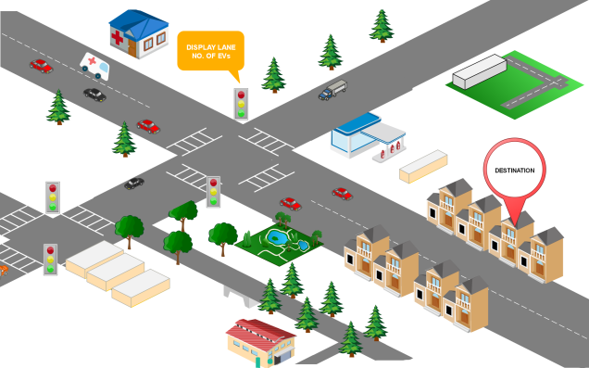

Figure 1. Ambulance going towards destination without any interruption.

III. EVMS(Emergency Vehicle Management System)

To wisely manage the Emergency vehicles, we have to implement a new system that work to eliminate the problem of managing Emergency vehicles traffic management, so to manage them firstly we need to track at what path they are coming and we need to aware the other vehicles on the road about the coming of the emergency vehicle so that they can move ahead and the Emergency vehicle will be able to reach its destination at time. To achieve this we are proposing our idea to manage this situation. Firstly a digital board will be installed at every traffic light that will show at what particular lane the vehicle is coming so that other vehicle on road know about the expected incoming of emergency vehicle, as the emergency vehicle is closer to the traffic light the lights of the traffic signal will be turn to Green (if the current status of signal is Red) and from which lane the emergency vehicle is coming will move ahead, when the emergency vehicle crosses the traffic signal the lights of the signal will be back to their previous state (if the lights were Red then it will again go to Red).

The Drive of an emergency will be provided with a mobile friendly Application in which he will enter his login details and after login in successfully, he can start his trip by simply entering his destination and will start his journey, now our system will detect all the traffic signal in his path and update all the digital board about his arrival on a particular lane, as the emergency vehicle will come closer example 100 meters to the traffic signals the signal will turn Green and as soon he crosses the traffic Signal the traffic lights will set to their previous state i.e. if the signal was Red it will again be Red and the digital board will be reset, if there is another emergency vehicle coming on the same path the digital board will be set according to that.

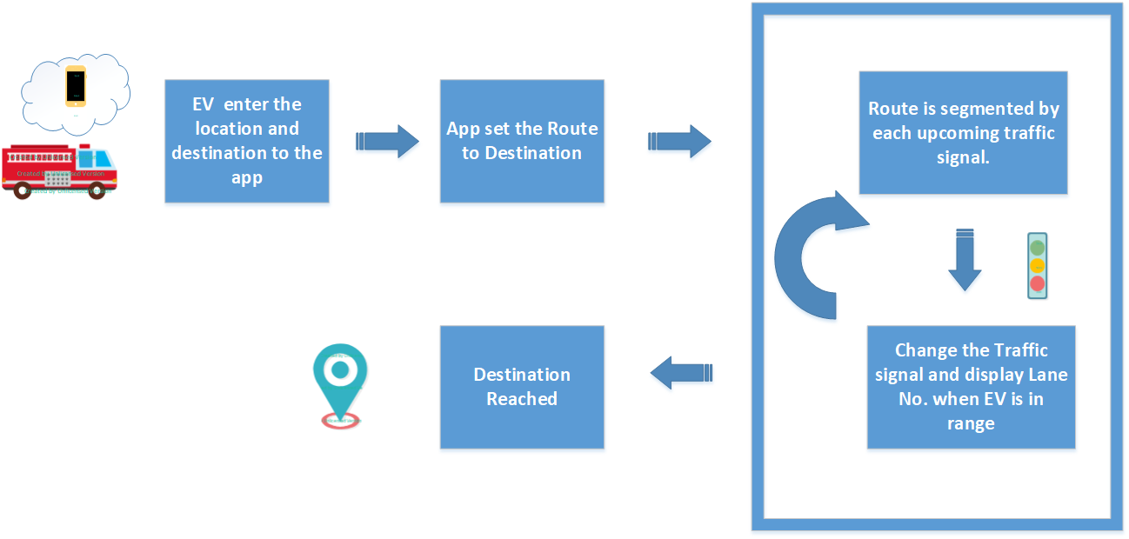

Figure 2. EVMS Work Flow

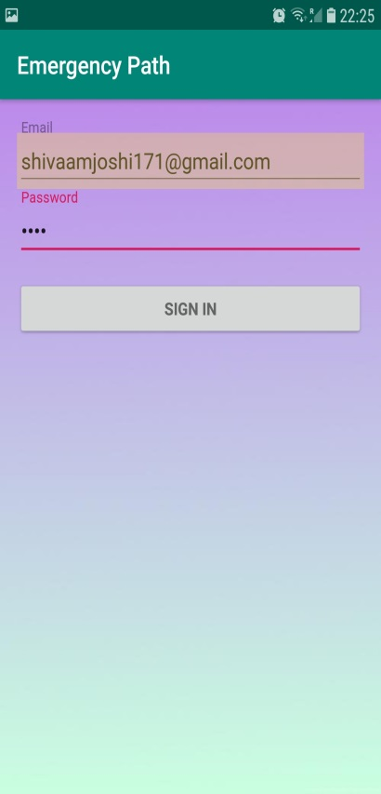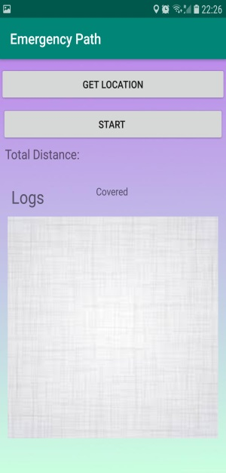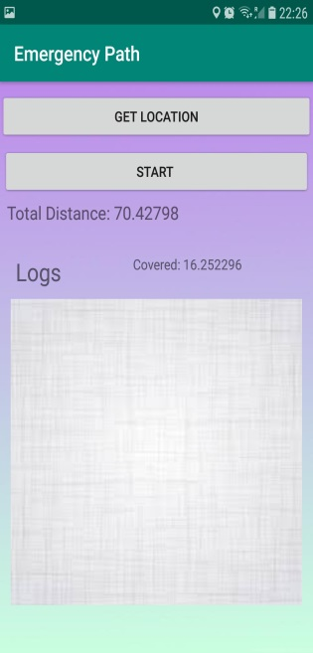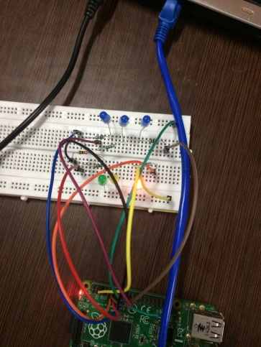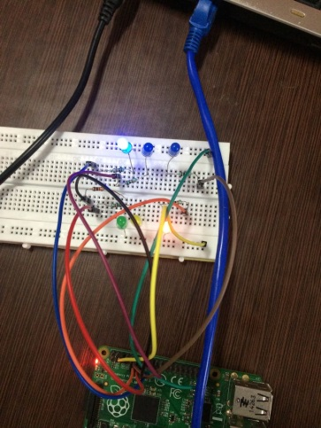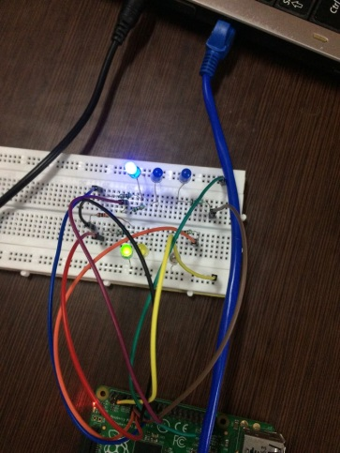

Figure 3. Mobile Application and Signal Flow

Steps

1. The user will open the application (Emergency Path) so that can pursue to his call.

2. A Unique Login Id and password will be provided each and every user so that no one can missuses the system (EVMS) as there can be many ill-usages it.

3. After the user is successfully login then the user can start the trip by simply tapping on the start button provided.

4. The destination for the user is pre-defined by the server as in an emergency situation it will be difficult to enter manually each time.

5. The location of the user is received by the GPS sensor which is in the mobile of the user, location of the user is processed as well the destination on the server side.

6. The server will make segments of traffic lights or signals which come in between the source and destination.

7. As the Emergency vehicle comes closer to the Traffic signal for example 10 Meters, the traffic signal will change to green, as soon the Emergency vehicle passes the signal are set to its previous state.

IV. Analysis

We are doing a comparative analysis with a pervious system purposed. On the bases of Accuracy, Technology, lane Detection and Security

.

|  |  |  |
| --- | --- | --- |
| **Parameter**  Table 1. Comparative analysis form an existing system Strobe Light | **EVMS** | **Strobe Light System** |
| Accuracy | High accuracy performance as using geo location | Low accuracy because climate conditions does not give accurate location |
| Technology | Using GPS | Using Strobe Light |
| Lane Detection | This method detect the lane, from which lane vehicle is coming | There is no lane detection mechanism in this method |
| Security | In this we use application, so unauthorized user cannot misuse the system. | Anyone can manipulate the system by their own strobe light |

Table 2. Time Analysis

|  |  |  |
| --- | --- | --- |
| **Time** | **STROBE LIGHT** | **EVMS** |
| Total Time | Total time is greater as the mechanism is lacking for future upcoming vehicle | Total time lesser than Strobe Light System |
| Average Time | Strobe Light can be manipulated so the average time is not accurate | By using GPS system, it always give accurate average time |

V. Conclusion

In this paper we talk about Big Data in Internet of Vehicle. Internet of vehicle is new emanating area, in which we can connect to various vehicles through internet and share valuable information. IoV can support the, storage of different sets of data, computing on them, big data acquisition etc. IoV is very helpful in traffic management system like we proposed a new methodology for emergency vehicles to reach the location without any traffic obstructions, for this we develop a app for current location of ambulance and this location sent to the traffic control room and according to the distance between ambulance and traffic signal the lights start working according to given parameter. This kind of system will help to decrease the death rate and also helpful to the society in future. This will help in coming future to properly manage traffic in optimized way.

**Reference**

[1] Jingwei Liu and Qingqing Li”MDBV: Monitoring Data Batch Verification for Survivability of Internet of Vehicles”, In proceeding of IEEE Access, Volume: 6, 2018

[2] Zhenyu Zhou1, Caixia Gao1, Chen Xu 1, Yan Zhang2, and Di Zhang3 “Reliable Content Dissemination in Internet of Vehicles Using Social Big Data”, In proceedings of IEEE Global Communications Conference, 2018

[3] Tao Zhong, Kshitij Doshi, Gang Deng Software and Services Group, Intel {tao.t.zhong, kshitij.a.doshi, Xiaoming Yang, Hegao Zhang Research Institute, “Volume Geospatial Mapping for Internet-of-Vehicle Solutions with In Memory Map-Reduce Processing”, In proceedings of IEEE International Conference on Big Data, pp 20-21, 2014

[4]Yang Zhao-xia.ZHU and Ming-hua ”Integration methods for wireless communication modes in IOV in Big Data”, IN proceedings of International Conference on Smart Grid and Electrical Automation, pp 602-607, 2014

[5]Tian Xiangjun “Research on Travel time prediction under IOV”, In proceedings of International Conference on Intelligent Transportation, Big Data & Smart City, pp 38-40, 2018

[6]Jeonghee Chi, Sunyoung Do and Soyoung Park “Traffic Flow-based Roadside Unit Allocation Strategy for VANET”, In proceedings of International Conference on Big Data and Smart Computing, pp 245-250, 2016

[7] Chaker Abdelaziz Kerrache, Carlos T. Calafate, Nasreddine Lagraa, Juan-Carlos Cano and Pietro Manzoni ”Trust-aware Opportunistic Dissemination Scheme for VANET Safety Applications” In proceeding of Intl IEEE Conferences on Ubiquitous Intelligence & Computing, Advanced and Trusted Computing, Scalable Computing and Communications, Cloud and Big Data Computing, Internet of People, and Smart World Congress ,pp 153-160, 2016

[8] Wenchao Xu, Haibo Zhou, Member, IEEE, Nan Cheng, Member, IEEE, Feng Lyu, Weisen Shi, Jiayin Chen, Xuemin (Sherman) Shen, Fellow, IEEE “Internet of Vehicles in Big Data Era” Volume: 5, Issue: 1 , pp 19-35, 2018

[9] Ishak Bin Aris, Ratna Kalos Zakiah Sahbusdin and Ahmad Fairuz Muhammad Amin “Impact of Big Data to Automotive Industry”, In proceeding of Asian Control Conference, pp 1-5,2015

[10] Mingming Zhang, Tianyu Wo and Tao Xi, “A Platform Solution of Data-Quality Improvement for Internet-of-Vehicle Services” In proceeding of IEEE International Conference on Pervasive Computing and Communications, pp 1-7, 2018

[11] Andre Luckow, Ken Kennedy, Fabian Manhardt, Emil Djerekarov, Bennie Vorster and Amy Apon ”Automotive Big Data: Applications, Workloads and Infrastructures” In proceeding of IEEE International Conference on Big Data ,pp 1201-1210, 2015

[12] Neeraj Kumar, Sudip Misra, Senior Member, IEEE, Joel J. P. C. Rodrigues,Senior Member, IEEE, and Mohammad S. Obaidat, Fellow, IEEE ”Coalition Games for Spatio-Temporal Big Data in Internet of Vehicles Environment “Volume-2 , Issue-4, pp 310-320, 2015

[13] Somwrita Sarkar, Sanjay Chawla, Shameem Ahmad, Jaideep Srivastava, Hosam Hammady, Fethi Filali, Wasim Znaidi, and Javier Borge-Holthoefer “Effective Urban Structure Inference from Trafﬁc Flow Dynamics” Volume -3,Issue -2, 2017

[14] Taku Noguchi, Naoto Tanaka “Efficient Vehicle Visualization System for Safe Driving in VANETs”, In proceedings of 2017 IEEE SmartWorld, Ubiquitous Intelligence & Computing, Advanced & Trusted Computed, Scalable Computing & Communications, Cloud & Big Data Computing, Internet of People and Smart City Innovation SmartWorld/SCALCOM/UIC/ATC/CBDCom